**Mod-1**

Model characterization refers to the process of describing and understanding the properties, features, and behavior of a model. It involves analyzing various aspects of the model to gain insights into its structure, assumptions, limitations, and performance characteristics.

Here are some key elements of model characterization:

1. **Structure**: Describing the components and relationships within the model. This includes identifying input variables, output variables, parameters, equations, algorithms, and any underlying assumptions.
2. **Assumptions**: Explicitly stating the assumptions made in developing the model. Understanding the assumptions helps users interpret the model's outputs and assess its applicability to different scenarios.
3. **Limitations**: Identifying the constraints or limitations of the model. No model perfectly represents reality, so it's essential to understand its limitations and potential sources of error.
4. **Validation**: Assessing the accuracy and reliability of the model by comparing its outputs to real-world data or other validated models. Validation helps establish confidence in the model's predictive capabilities.
5. **Sensitivity Analysis**: Analyzing how changes in input parameters or assumptions affect the model's outputs. Sensitivity analysis helps identify which factors have the most significant impact on the results and how robust the model is to variations in input.
6. **Uncertainty**: Characterizing the uncertainty inherent in the model outputs. This involves quantifying uncertainties in input data, parameters, and assumptions and understanding their implications for decision-making.
7. **Performance Metrics**: Defining metrics to evaluate the performance of the model, such as accuracy, precision, bias, and computational efficiency. These metrics help assess the model's suitability for its intended purpose.

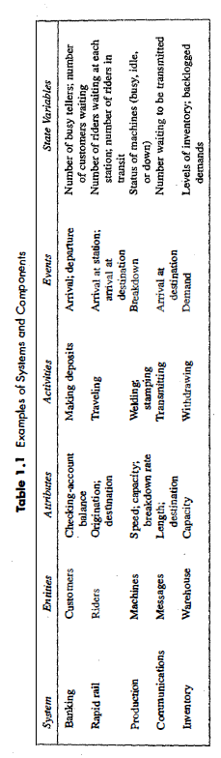

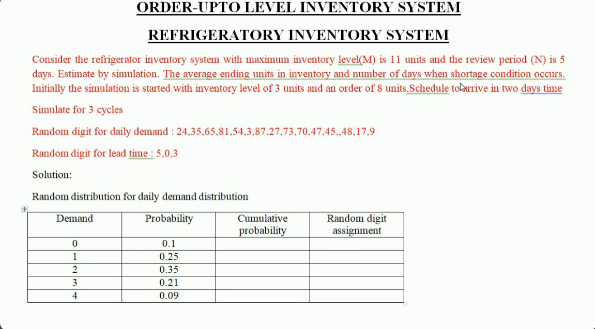

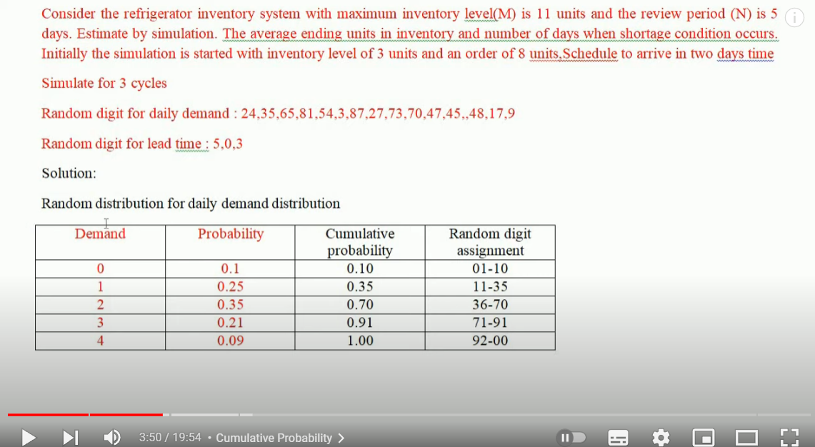

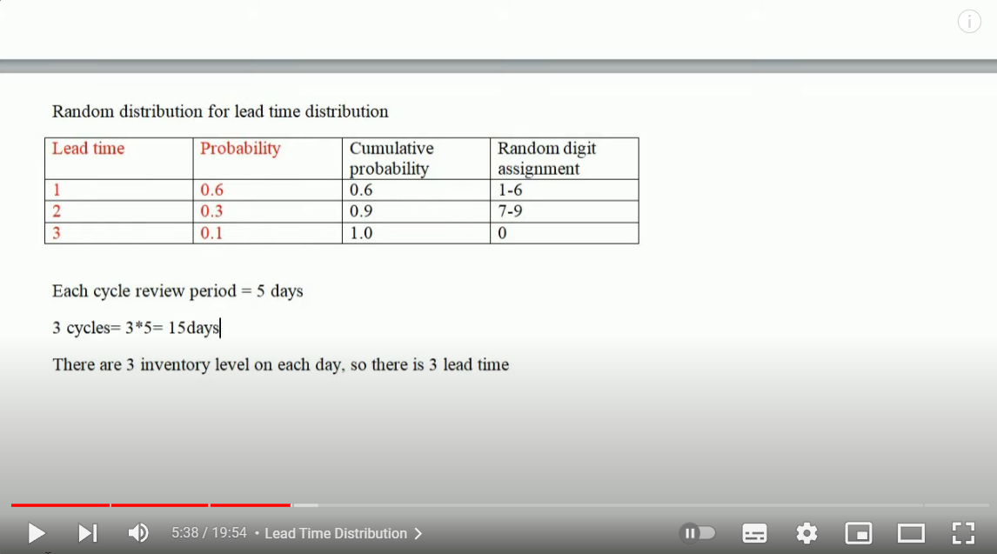

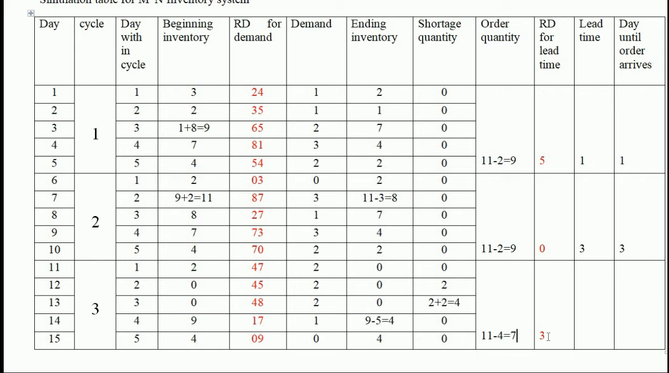

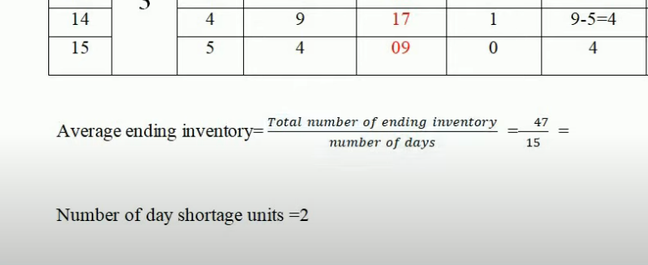

**Mod-2**

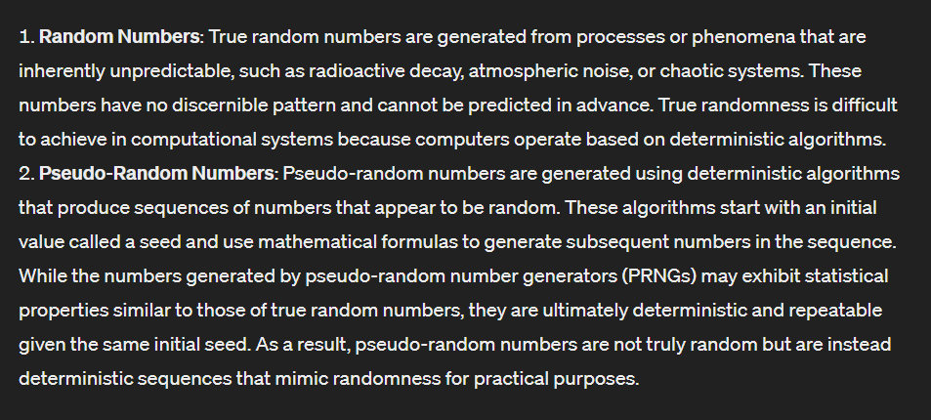

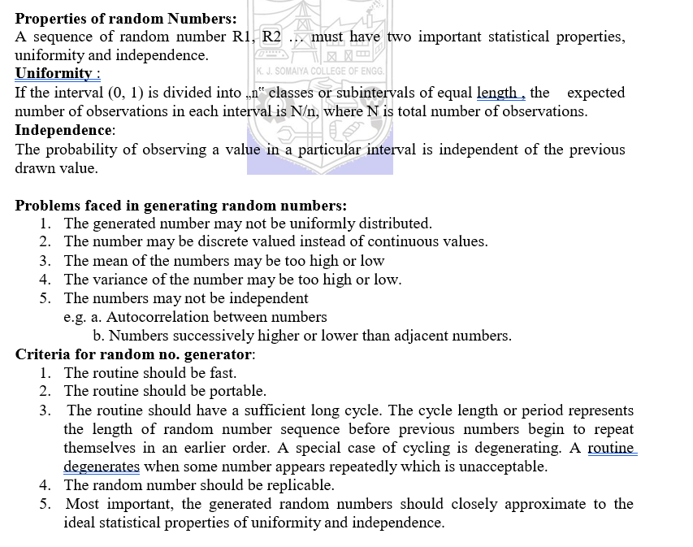

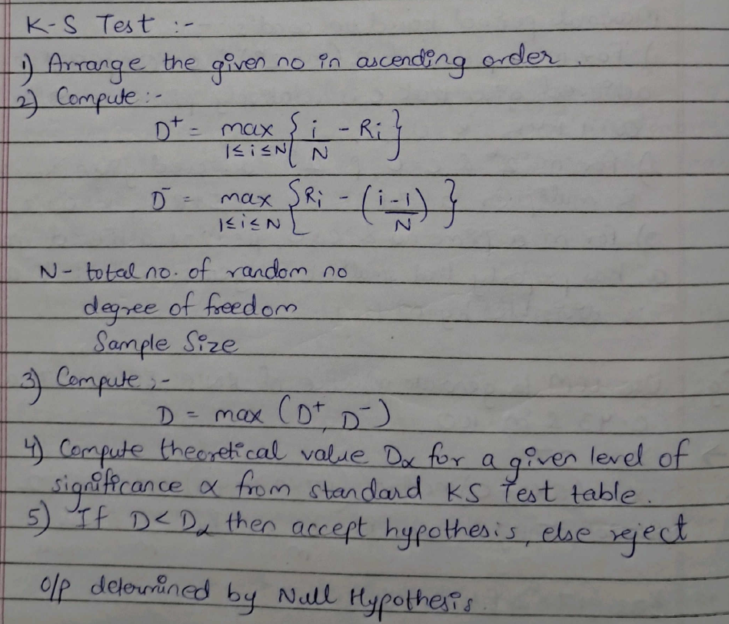

**For chi square test sample size n ke lye kitne interval lene hai**

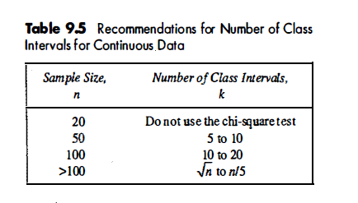

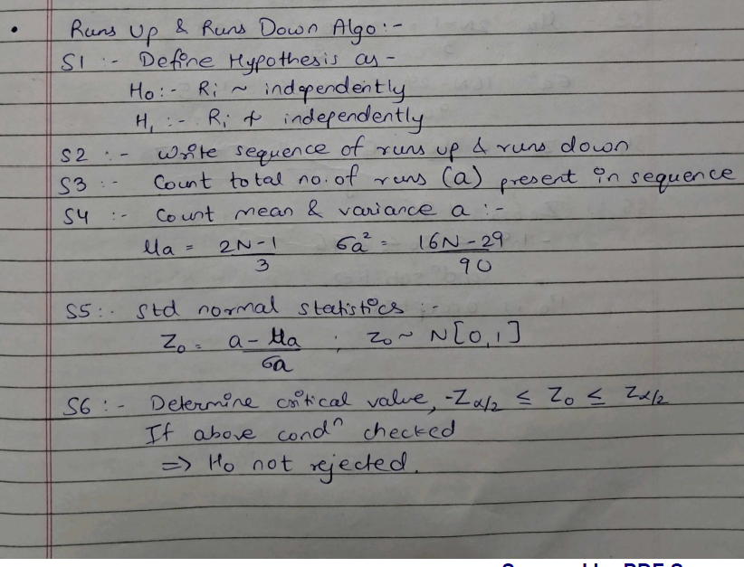

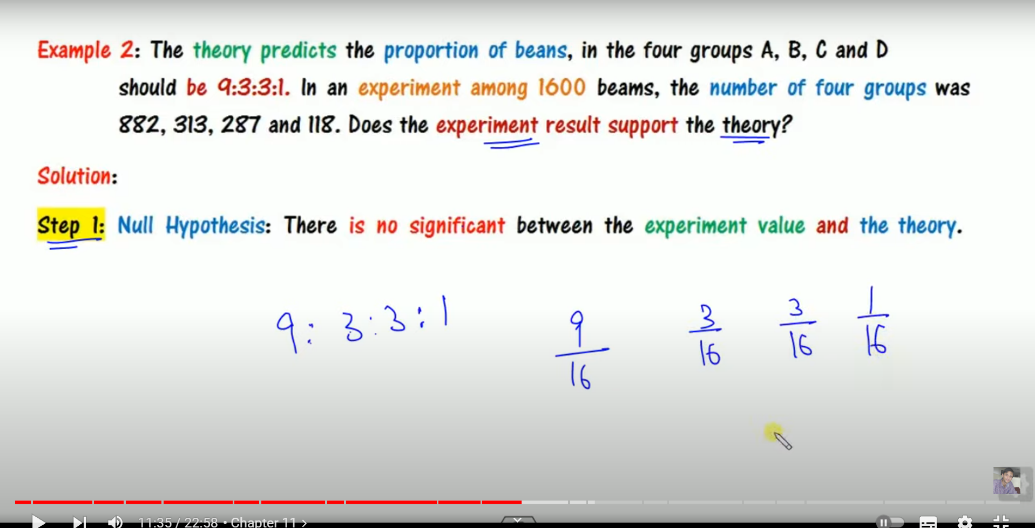

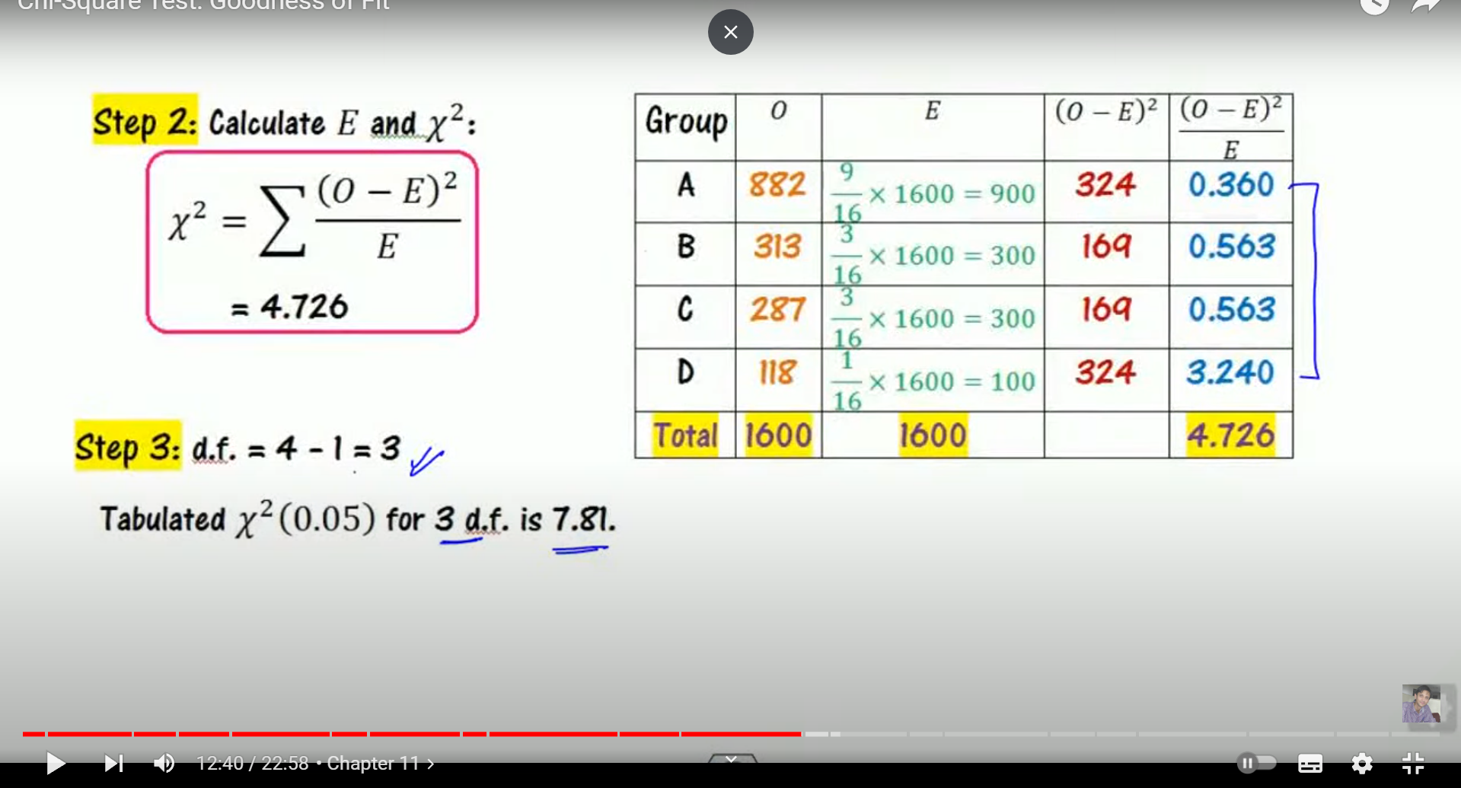

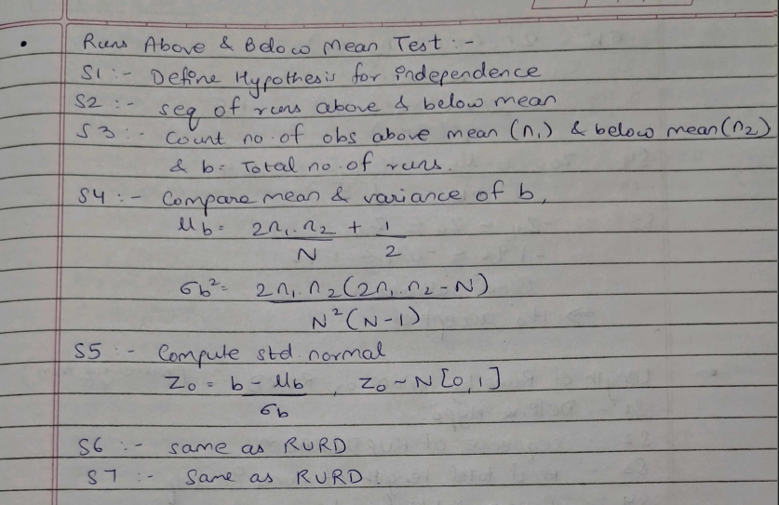

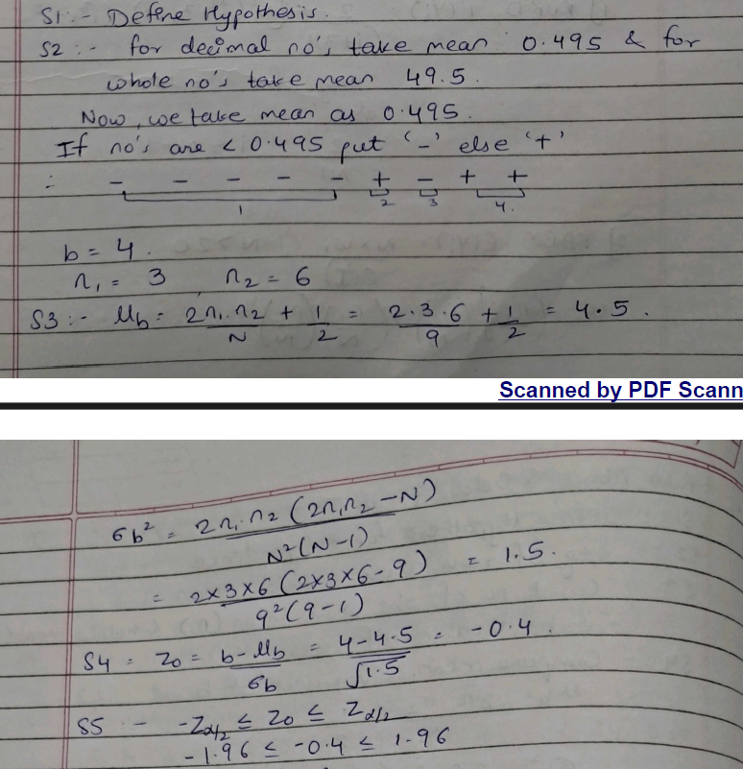

**Mod-3**

**Mod-4**

**Binomial**

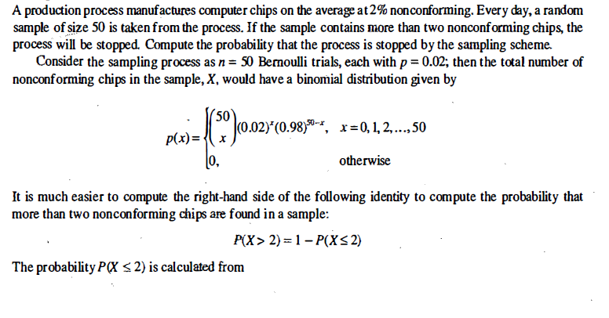

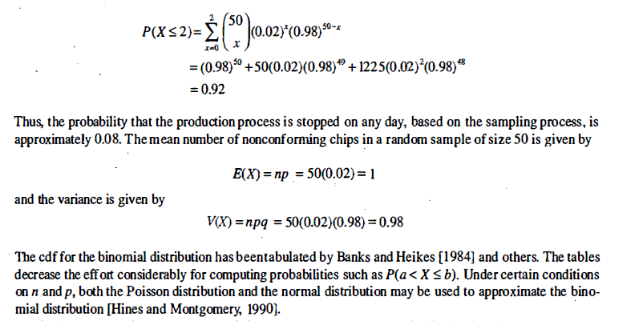

Certainly! Let's explore random sampling and shuffling in detail:

### 1. Random Sampling:

**Definition**: Random sampling is a method used to select a subset of individuals or items from a larger population in such a way that each member of the population has an equal chance of being selected. It is widely used in statistics, research, and data analysis to obtain representative samples for analysis.

**Techniques**:

- **Simple Random Sampling**: Each member of the population has an equal probability of being selected, and every possible sample of a given size has the same probability of being chosen.

- **Stratified Sampling**: The population is divided into homogeneous subgroups (strata), and samples are then randomly selected from each subgroup.

- **Cluster Sampling**: The population is divided into clusters, and a random sample of clusters is selected. All individuals within the selected clusters are then included in the sample.

- **Systematic Sampling**: Members of the population are selected at regular intervals, using a fixed sampling interval.

**Applications**:

- Opinion polls and surveys

- Market research

- Quality control in manufacturing

- Medical studies and clinical trials

- Environmental studies

**Benefits**:

- Representative samples: Random sampling helps ensure that the selected sample is representative of the population.

- Unbiased estimates: Random sampling reduces the risk of bias in estimates and results.

- Statistical validity: Random sampling provides a basis for making statistical inferences about the population.

### 2. Shuffling:

**Definition**: Shuffling is a process of randomizing the order of items in a collection. It is commonly used in various applications such as gaming, data analysis, and cryptography.

**Techniques**:

- **Fisher-Yates Shuffle (Knuth Shuffle)**: A popular algorithm for shuffling a sequence of items. It iteratively selects a random element from the unshuffled portion of the list and swaps it with the last unselected element.

- **Random Permutation**: Generating a random permutation of the items in the collection using a random number generator.

- **Cryptographic Shuffling**: Shuffling methods designed to ensure randomness and unpredictability, often used in cryptographic applications.

**Applications**:

- Randomizing decks of cards in card games

- Shuffling playlists or recommendations in music and video streaming services

- Data shuffling in machine learning and data analysis to ensure randomness and prevent bias

- Shuffling cryptographic keys and data to enhance security and privacy

**Benefits**:

- Randomness: Shuffling ensures that the order of items is unpredictable and random.

- Fairness: In gaming and competitive scenarios, shuffling ensures fairness by preventing players from predicting the order of items.

- Security: In cryptography, shuffling enhances security by introducing randomness and preventing attacks based on predictable patterns.

In summary, random sampling and shuffling are important techniques used in various fields for obtaining representative samples, randomizing data, and ensuring fairness and security. Understanding these techniques and their applications is crucial for conducting unbiased research, analysis, and decision-making.

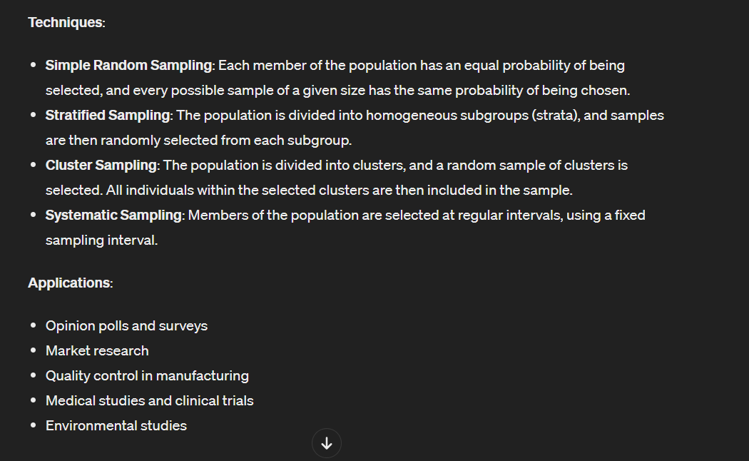

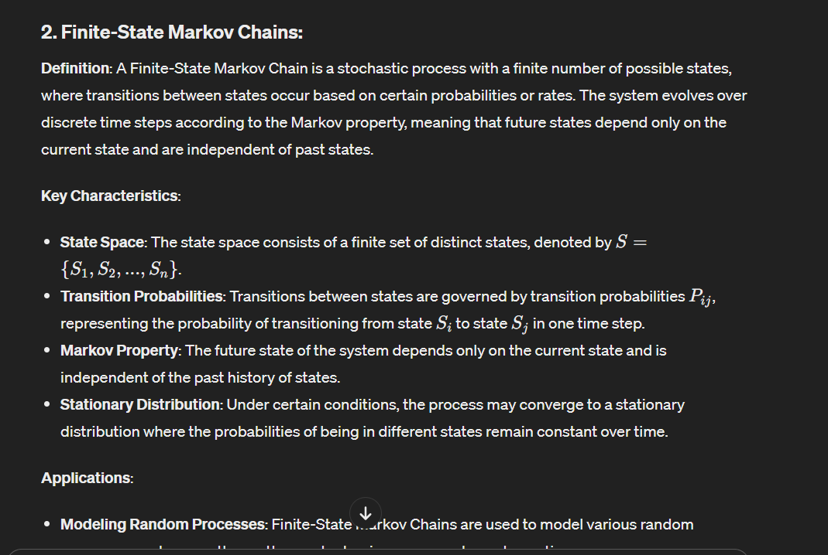

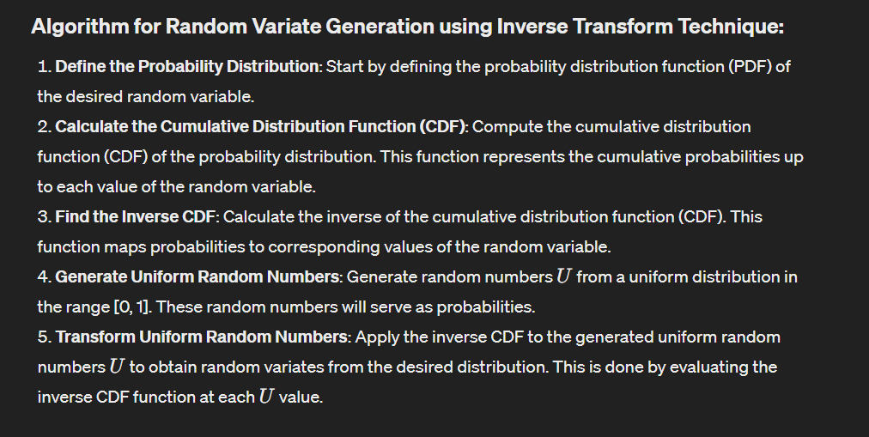

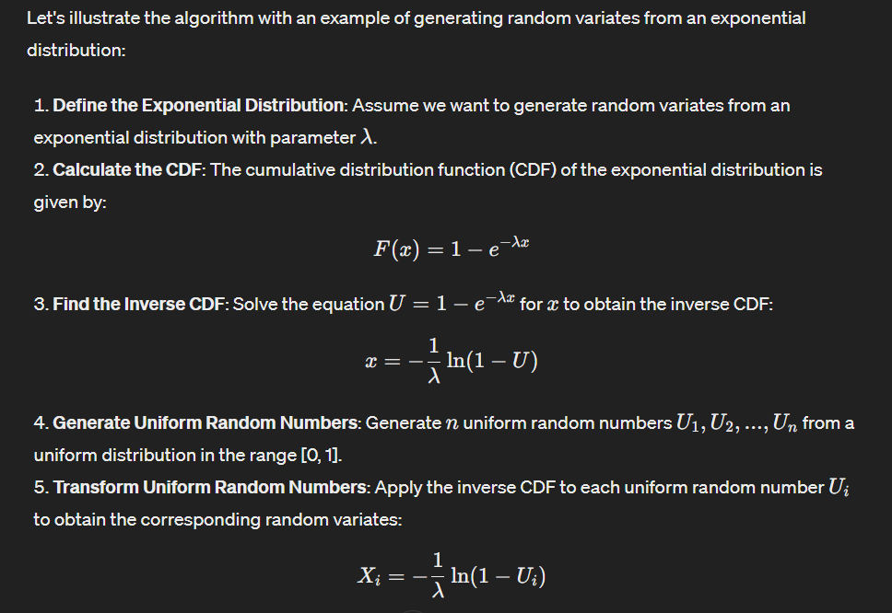

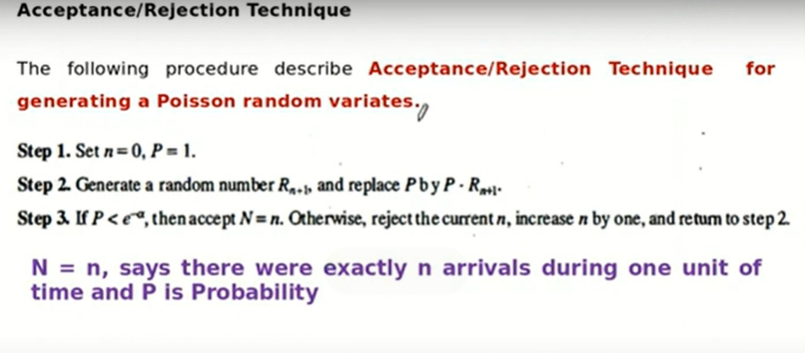

**Mod-5**

